Prepare for Your Passport Appointment

Review the information provided for you at stanlaw.org/passports.htm This will improve your odds of being able to submit your application successfully.

- Arrive on time, and come inside no more than 10 minutes before your appointment. If you are late, we will be unable to process your application.

- Bring your library voice. The Law Library is a quiet place; our users are working on legal projects. Please respect the quiet professional atmosphere of the space. Cellphone use is not allowed in the Law Library.

- Check your documents ahead of time. If we are unable to process your application because of improper documentation it will significantly delay your application process. You need originals plus photocopies before you come.

Bring the attached checklist with you to your appointment

Facility Parking
We are located at 1101 13th Street in Modesto, California. We have limited parking in our parking lot with its entrance on K street. The facility entrance doors on that side will be electronically locked. Please do not park in spaces marked Reserved or those with a number painted on the space.
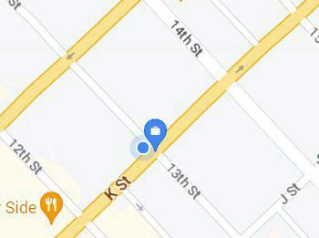
Note: There is ample parking on 13th Street, and the entrance on that side of the building is generally unlocked during passport acceptance hours. Should it be locked please ring the doorbell located on the left wall next to the entrance on the other side of the building.

PASSPORT APPOINTMENT CHECKLIST

All Applicants
APPLICATION: I have completed DS-11 form (black ink, single-sided) for each applicant and the document is UNSIGNED.
PROOF OF CITIZENSHIP: I have brought an ORIGINAL PROOF of CITIZENSHIP
and a PHOTOCOPY for each application.
PRIMARY IDENTIFICATION: I have brought ORIGINAL IDENTIFICATION and a
PHOTOCOPY for applicants age 16 and older.
PASSPORT PHOTO: I have brought a recent 2”x2” photo taken in the last 6 months and understand that the Law Library does not take photos.
STATE DEPARTMENT PAYMENT: I understand that I will need one personal check/cashier’s check/money order for payment to the U.S. Department of State. (No cash).
FACILITY PAYMENT: I understand that I will pay a separate processing fee to the Stanislaus County Law Library by cash, debit card or money order.

Additional Requirements for Children under age 16 (Copies are required for each applicant)
PRIMARY IDENTIFICATION FOR PARENTS: I have brought ORIGINAL
IDENTIFICATION and a PHOTOCOPY for both parents of applicants under age 16.
PARENTAL RELATIONSHIP: I have brought proof of parental relationship (i.e. birth certificate) Names match or certified name change documents and court documents.
APPEARING PARENT/GUARDIAN: I have brought both parents to appear in person or the non-appearing parent has completed and notarized form DS-3053 or submitted a notarized letter authorizing the other parent to apply for the child’s passport. All letters & DS-3053 forms must include a legible photocopy of the front and back of the non-appearing parent’s valid IDENTIFICATION.

Failure to bring all required documents, will require rescheduling of your appointment. It may be several weeks before another time is available. This list contains basic requiments and additional documentation may be required.

PAYMENT # 1 US DEPARTMENT OF STATE FEES
You MUST have a PERSONAL CHECK, CASHIER’S CHECK or MONEY ORDER to pay directly to the U.S. Department of State. (No cash will be accepted)

 | Fee |  | Quantity |  | Totals
Adult Passport (16 and Older) | $130.00 | X |  | =
Adult CARD (16 and Older) | $30.00 | X |  | =
Child Passport (Under 16) | $100.00 | X |  | =
Child CARD (Under 16) | $15.00 | X |  | =
Expedite Fee | $60.00 | X |  | =
1-2 Day Delivery | $19.53 | X |  | =
PAYMENT # 1 TOTAL |  |  |  | =

PAYMENT # 2 FACILITY PROCESSING FEES
You MUST have CASH. DEBIT CARD or MONEY ORDER to pay directly to the Stanislaus County Law Library

 | FEE |  | Quantity |  | Totals
Processing Fee | $35.00 | X |  | =
Express Mail 1-2 Day Delivery | $24.90 | X
PAYMENT # 1 TOTAL |  |  |  | =

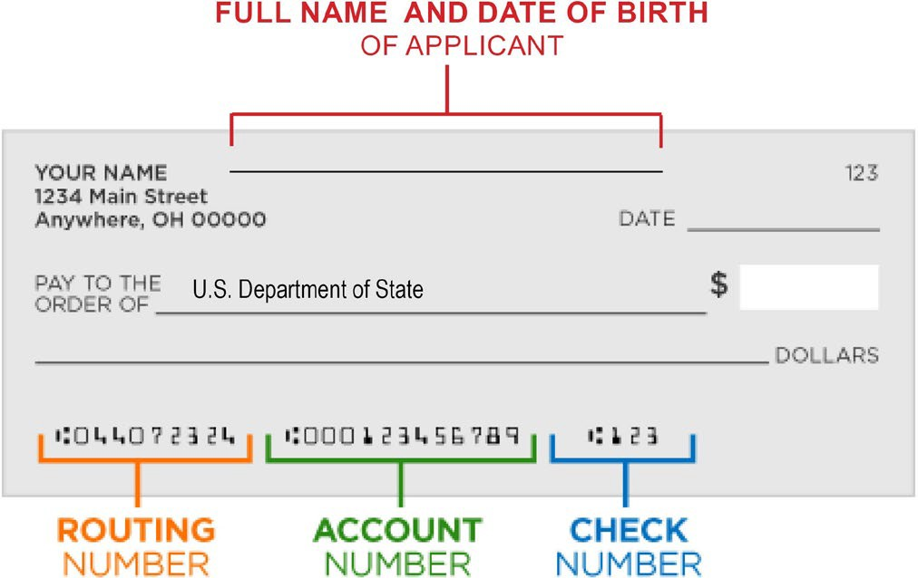
PLEASE NOTE THERE ARE TWO SEPARATE PAYMENTS

- Personal check, cashier's check or money order payable to the US Department of State. (No cash or card) With applicant info as shown on the right.

- Cash, Check, Debit Card or Money order payable to the Stanislaus County Law Library.

